Review + Create

Applying tags via Azure Policy

Delete assignment

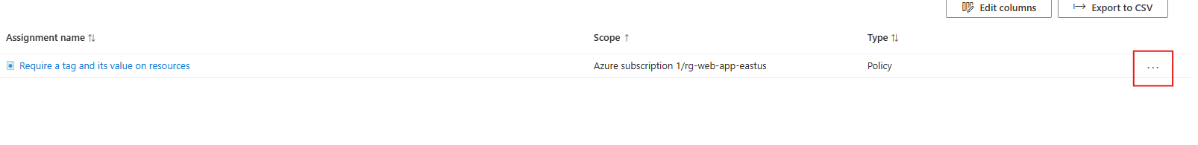

Create Storage account to verify policy

Configure and test resource locks

Bonus: remove lock to delete Resource group

